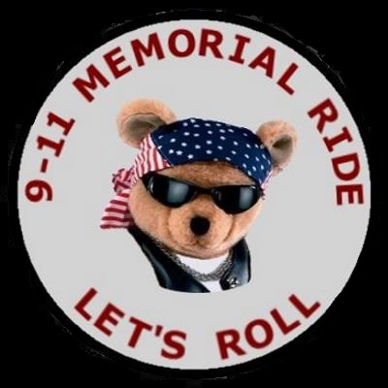  - September 10th 2017  5th Annual  Lets Roll 9-11 Memorial Ride  Sponsored By Sons Of Liberty Riders MC  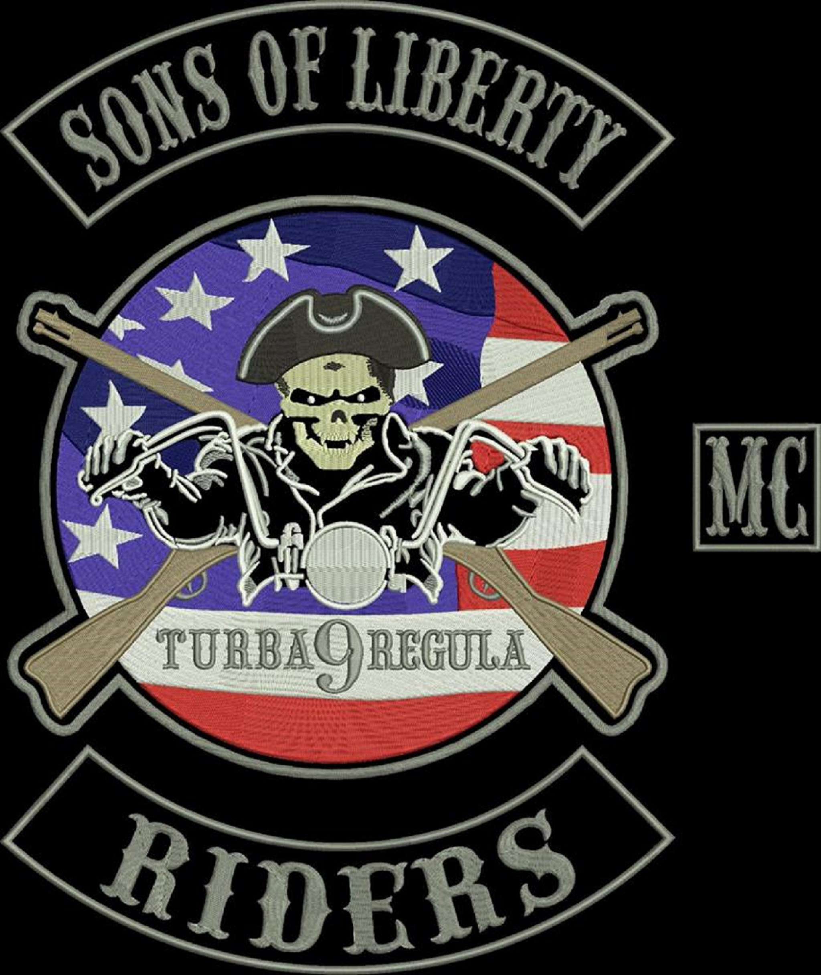The ride is in honor of the 8 children who died on 9 11, the more than 3000 children left without mothers and fathers, the flight crews, the first responders, our troops, and Americans who've died in terrorist attacks since,  Riders Gather 12 noon at Dallas Harley Davidson 1334 west Centerville rd., Garland Texas - kick stands up 1pm sharp for the Grapevine Flight Crew Memorial – Arrival Grapevine Flight Memorial aprox, 3:PM where ceremony commences.  Please RSVP Facebook Events  The Original Lets Roll 911 Memorial Ride. |  | Ride Escorted By Dallas Sheriff’s Department  The 2017 ride will take us through downtown Dallas, across the designer bridges, past the DFW National Cemetery, then on to the Flight Crew Memorial, at 1000 Texan Trail  Ceremony’s Guest Speaker TBA  You Can Sponsor A Biker Bear $50 See Details Texas Biker Radio .org  Special Thanks To Grapevine Flight Crew Memorial Foundation  Sons Of Liberty Riders  817-676-3730  sonsoflibertyriders,org  September 10th 2017  gunbarreltx@gmail.com
Note: Non-Motorcycle Riders Welcome to Attend Ceremony 3PM

